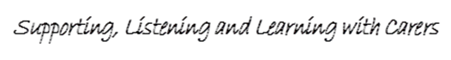

***24th November 2015***

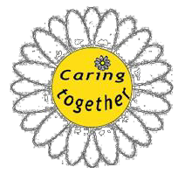

***The Conference Report***

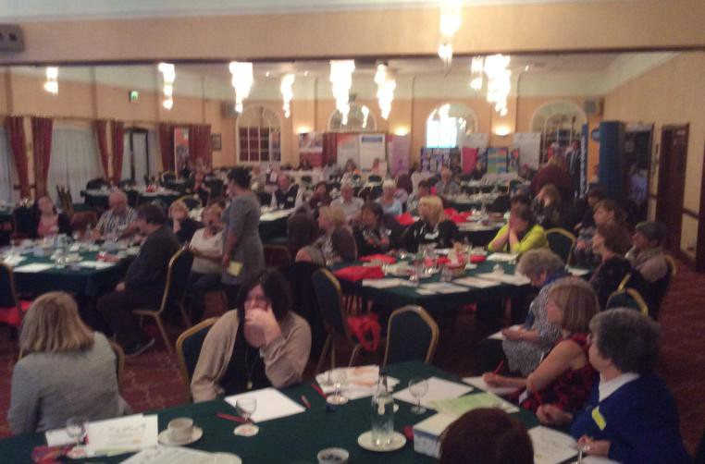

***Report Author: Naheed Ashraf***

***Date: 30/12/2015***

***Acknowledgements***

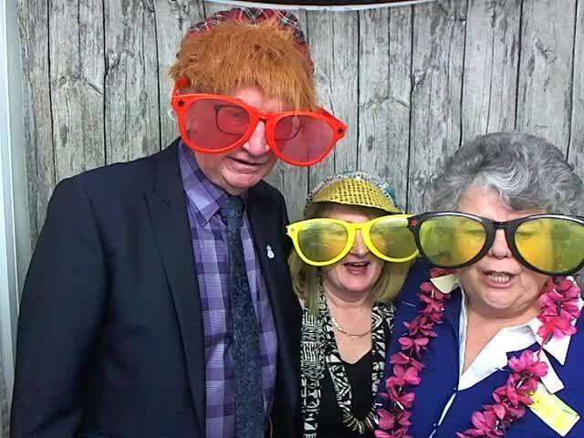

*Our second Carers conference ‘Caring Together’ was a committed effort from both Carers and professionals who play such an important role in helping us to make a difference and deliver improvements.*

*All 5 Gwent Local Authorities, Third Sector, Carers and the Health Board have worked hard to ensure people had the opportunity to listen and learn. We are*

*thankful to all delegates, presenters, exhibitors, information providers and raffle prize donors who supported this event.*

*It is through engagement events like this that we are able to learn and improve. We would like to thank those Carers and professionals who made time available for this event to contribute their valuable views and share their experiences. We would also like to acknowledge the work of the Conference organising committee in facilitating the event*

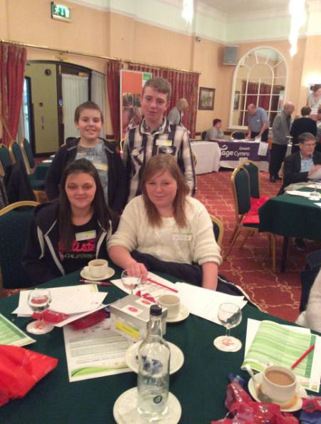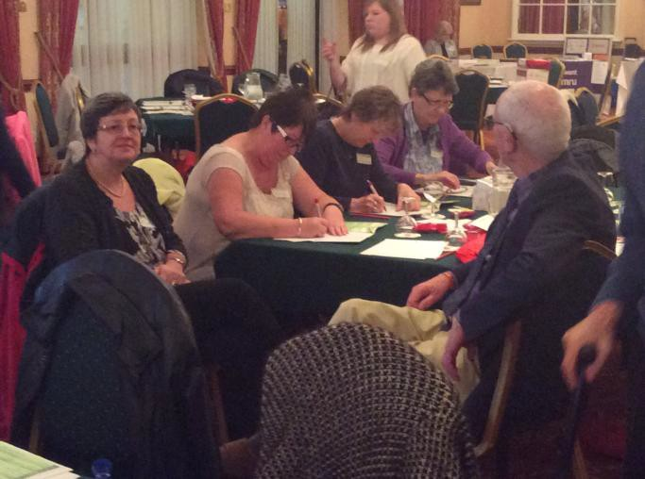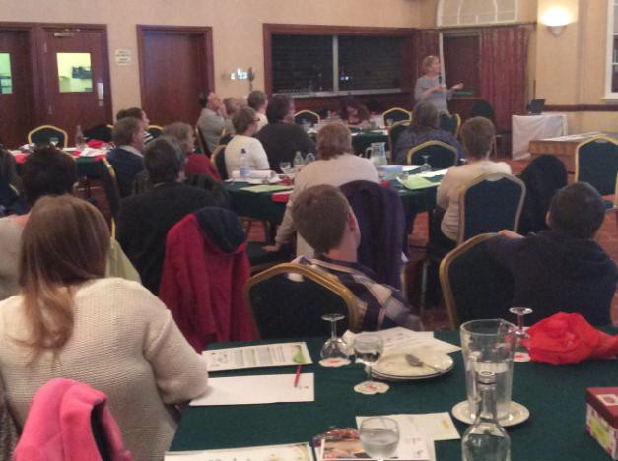

**Contents**

**1.0 Executive Summary ........................................................................4**

**2.0 Background .....................................................................................4**

**3.0 Welcome ..........................................................................................6**

**4.0 Key Note Address -Welsh Government.........................................6**

**5.0 Carers Stories .................................................................................7**

**5.1 Hospital Gardens ............................................................................7**

5.2 Mrs Coleman’s Story ........................................................................................ 8

**5.3 Gary Farr** ......................................................................................................... 8

5.4 Young Carers.................................................................................................... 9

5.5 Daniel Madge – A Parent Carer...................................................................... 11

**6.0 Workshops ....................................................................................12**

6.1 Coping with caring .......................................................................................... 12

6.2 Putting Things Right ....................................................................................... 15

6.3 Networking and Social Media -Get Connected ............................................... 18

**7.0 Mindfulness ...................................................................................20**

**8.0 Evaluation......................................................................................21**

**9.0 Conclusion ....................................................................................21**

**Appendix A..........................................................................................23**

**Appendix B..........................................................................................25**

**Appendix C..........................................................................................27**

**Appendix D..........................................................................................28**

**1.0 Executive Summary**

On 24th November 2015 Aneurin Bevan University Health Board Partnership area hosted its second Carers Conference.

We were pleased to welcome around

120 delegates including professionals and Carers of all ages and backgrounds. The overall theme of the day centred on feedback we received from last year’s conference where delegates requested the opportunity to be listened to, share personal experiences and have the opportunity to attend several workshops.

We heard from Welsh Government and other speakers, mainly Carers, and provided delegates with the

opportunity to network as well as share their experiences and expertise

We recognise that Carers need to be listened to and respected as expert partners in care. Over the past year we have concentrated on addressing issues raised by carers at the 2014 conference. **Appendix A** highlights the various activities and actions implemented by the Partnership in this regard.

This year we provided a range of opportunities in order to gather more feedback from Conference delegates including the use of comment boxes on each table, an evaluation booth, discussions at workshops and film

footage during the day for delegates to record their views.

We have worked very hard to collectively create a positive and inclusive ethos throughout our approach to improving information and support for carers. Based on feedback received at the Conference, we will continue to work in partnership with Carers, Third sector, Local Authorities and Health Board in order to successfully address the issues raised.

This conference allowed us to refocus on improving services for carers and we acknowledge that 2016 is an exciting year of change with the implementation of the Social Services

and Wellbeing (Wales) Act which gives Carers a right to an assessment and support that equals the rights of those they care for.

**2.0 Background**

Over the past 4 years we have worked in partnership with our Local Authorities, Third Sector and Carers to deliver our Carers Measure

Information and Consultation Strategy. Its three main objectives being

Carers are identified at the earliest point of contact



The effective provision of relevant, up to date and targeted information to Carers



Carers are informed of their legal right to an independent assessment of their own needs



Implementation of the strategy has been based on a number of targeted work programmes, progress against

which is overseen and steered by a

Programme Board.

Key progress has been made including staff training, greater awareness and identification of Carers, working with GP’s and primary care and strengthening networks and partnerships with education and schools to raise awareness of support to Young Carers. These work streams sit alongside wider initiatives that feed into implementation of the

requirements of the Carers Measure

We have been keen to find ways to identify and raise the profile of carers, signposting them to relevant support services.

Over the next year new legislation will require a greater emphasis on strengthening existing partnership networks to deliver a holistic approach, ensuring Carers remain a key area of

work.

All those attending the conference *were* able *to* listen *to* presentations, *Carers* stories*,* take part in workshops where they were able to ask questions and discuss issues thus maximising opportunities for carers to speak and express their opinions and concerns

The event concluded with a mindfulness session which gave delegates the opportunity to relax and think about their own health and wellbeing.

*“This was so useful. It taught me not to get caught up with thoughts and feelings. It changes how you respond to these and how to think about me”*

*A Delegate*

***“We’ve been caring for a few times over the years and one thing I will say is that we struggled as we had a young family and very little help. Over the years things have improved greatly and we are more than pleased with the way things are going. There are now a lot***

***more services for Carers”***

*“This event can open up some opportunities. This isn’t about finishing something, it’s about starting something, and if we can do this right, I see no reason why we can’t go onto much greater things in the future.”*

*A delegate*

**3.0 Welcome**

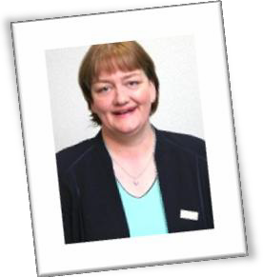

Denise Llewellyn, Nursing Director and Chris Koehli, an accountant, independent member of the Aneurin Bevan University Health Board (ABUHB) and ABUHB Carers champion, welcomed everyone to the event.

“We are here today to recognise that Carers provide care for loved ones, families and friends. Everybody at some point in their lives will be carers and we recognise that caring can be demanding and challenging, have an adverse affect on Carers health and

wellbeing and can lead to isolation. But there are also positives with every carer’s situation being different. It is important that there is provision of support services for the valuable work that Carers do “

Chris informed delegates that the content of the conference was based around feedback from last year’s conference where we were encouraged to use more carer’s stories and provide a greater opportunity for delegates to attend more workshops.

He stressed that the event was also an opportunity to network, meet and make new acquaintances and continue collaborative working in partnership

with carers.

**4.0 Key Note Address -Welsh**

**Government**



Andrea Nicholas-Jones, Head of Older People and Carer’s Strategies, Integration, Policy and Delivery Division, Welsh Government set the scene by delivering the keynote address.

Andrea introduced the new Social Services Wellbeing Act 2016 and also made reference to the Wellbeing of Future Generation Act, both of which will be implemented from April 2016. The importance of carer’s rights was stressed where the Social Services Wellbeing Act places carers on an equal footing to those cared for. Emphasis was placed on the requirement for Local Authorities and Health Boards to work in partnership to recognise the reciprocal role they play in delivering this new legislation*.* Another important part of the Act stipulated was providing information, advice and assistance and giving

carers the option of opting out of any obligation they may feel in providing care. Welsh Government saw the conference as an opportunity to share

solutions and good practice and urged delegates to have a voice and work together to meet the challenges

ahead.

*I made good contacts/ networking at the conference. I enjoyed meeting other carers and am pleased to learn of changes at Welsh Government level and learn to see how this makes life better for me.*

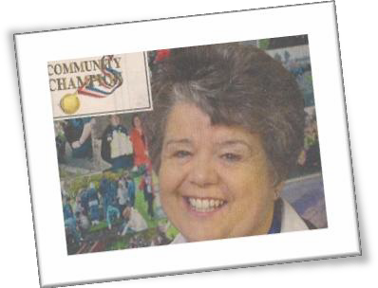

**5.0 Carers Stories**

***5.1 Hospital Gardens***

Carol shares her story of how getting involved in an activity helps the health and wellbeing of Carers. A passionate

and enthusiastic presentation was delivered about Carols work in Hospital Gardens.

Carol used her initiative by including patients to help transform unkept hospital gardens. Following fund

raising and a contribution from Melin Homes, patients were involved in ideas, design and even a choice of plants for the gardens.

Carol encouraged Carers to try to get involved in some activity even if it is only for an hour and stressed the positive impact this has on health and wellbeing.

“I remember a gentleman who had never spoken before singing at the top of his voice”

Carol was commended for her efforts by Dawn Morgan (ABUHB Senior nurse atTy Siriol) stating that the work done is phenomenal and that she was pleased to see patients, staff and relatives sit outside on the benches and see the satisfaction gained from their planting.

She concluded by saying that “Carol is not a staff member of the Health Board but is such an important member of the team”

As a result of Carols work Ty Siriol are now setting up a volunteer project. The only criteria being that not only you

care for someone else but the first step being that “you care for yourself.

“Without these projects and the two carers groups I would probably be ill myself”

Carol Wheeler

**5.2 Mrs Coleman’s Story**

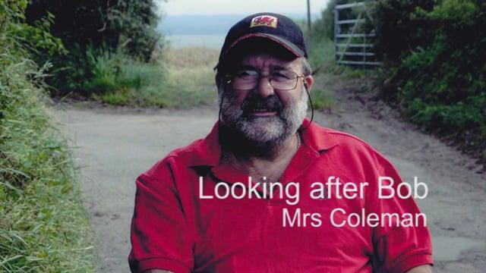

A DVD was shown about Mrs Coleman who looks after her husband Bob. Bob has Parkinson’s disease and has been suffering from a series of health problems following a heart attack and stroke. The DVD showed how Mrs Coleman, planning to enjoy life after

the sale of a business, suddenly found herself in a caring role.

Mrs Coleman talks honestly about her husband’s illness and how other events such as a loss of a pet triggered her husband’s mental health problems. She speaks about her

caring role and the impact of caring on her own health and well-being and using paid care workers to assist.

**5.3 Gary Farr**

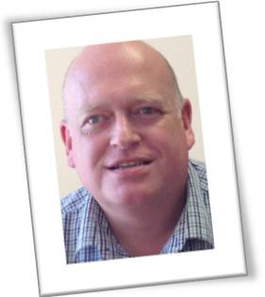

After his father’s sudden death in

2011, Gary found himself as a Carer for his mum. Later that year, Gary had major spinal surgery and in 2013 was involved in a major car accident which caused more damage to his spine/back.

Gary shares his success of teaching his mum, who is deaf, to communicate via an iPhone – which was a challenge after she had a stroke 18 months ago.

*“I had Carers but didn’t want them. I thought I’m supposed to be looking after him. He’s my husband and then on the other hand you feel that exhausted at the end because you are literally caring 24 hours a day and you just feel so tired and you think don’t want people in and out of your house. I’m just too tired to be bothered. Then I think its more work for*

*me because I have to be up in the morning*

*hoovering and dusting and squaring up before they come. Carers are great as Bob doesn’t talk a lot so I’m here all day with no one to talk to. So I talked to her “*

*I found myself as a carer.*

*It wasn’t something I thought about but something I had to do*

Gary works part-time as well as caring for his mum. Gary’s mum is profoundly deaf and lived in west Wales and he lived in Newport. It often took him

more than 5 hours to catch a train and back to visit. Whist his mum could look after herself, she couldn’t cope with

the garden. That was something his father always did. With the onset of winter his mother became housebound and frightened to go out. Things came to a head and following Gary having 6 discs removed and a major accident. He was classified disabled at 45 years of age whilst he was a carer for his mother.

Gary found himself, at the age of 45, disabled looking after his disabled mother.

He moved his mother to Newport into sheltered accommodation and 18 months ago she suffered a stroke. Gary still helps with the shopping and getting his mum out and about. Gary communicates with his mum via iPhone and tablet and this technology ensures his mum is not lonely.

*She’s my mum. I can’t live with her and certainly can’t live without her. My*

*mum brought me into this world, its my responsibility as her only son to ensure she reaches the finishing line with all*

*the love , help and compassion I can give her and although it can be hard I*

*wouldn’t change my life one bit”*

**5.4 Young Carers**

A powerful introduction to Caring was delivered by a group of Young Carers aged 12 to 15 who shared their experiences.

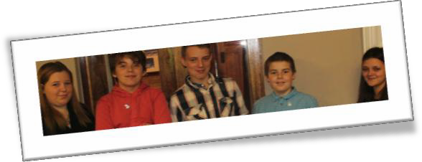

These stories helped provide a better understanding of the issues/barriers that young carers face and reinforces the need for support services to be in place

*Opened my eyes about young carers. More needs to be done. These kids are our future they need to be looked after better. Develop a package /folder/ app for children so they don’t have to keep telling social services etc their story, they should be able to read up before they meet them and prevent any*

*further stress and deal with issues they have rather than spend half their time telling their stories. Get*

*the kids on video set their stories out there – THEY*

*ARE NOT ALONE. FAB EVENT.*

*9*

*One young Carer is 15 years old and has been caring since the age of about 7 or 8 for their mother who suffers mental health and back problems and also their younger sister. Their caring role means that they helps to get their sister ready for school get mum out of bed and clean the house. They have been involved with social services and were involved in foster care. By the age of 15 they had 17 social workers and found themselves repeating their life history with each one. Since*

*being involved in the young carers projects their confidence and self esteem has been boosted and their attendance at school has improved. They were signposted to other services such as CAMHS and now acts as a peer mentor and volunteer to help other children*

*A young carer is 13 years old and has been a young carer since the age of 10. They were involved with Barnardos since the age of 5.*

*They became young carers as their father, a single parent, was drinking a heavy amount of alcohol.*

*“ Being a carer made me feel like it was the right thing and made me feel like I was being helpful but being a carer made me feel I had to grow up faster”*

*They would also help with their younger brother when their father was struggling and feared that social services would become involved. Eventually they moved home and live happily with their aunty and uncle who they now call mum and dad. They have also become a*

*Barnardos volunteer*

*A Young carer is 12 years old, and cares for mum.*

*They help with shopping, cooking, looking after their sister*

*“I keep asking my mum if she’s ok and if there’s anything I can do before I go to school. But when I’m at school I worry about my mum and keep asking*

*myself the same question – Is she going*

*to be ok?*

*Sometimes I feel like exploding and frantically fit in as much as I can. Barnardos has helped relieve stress off*

*me “*

*“I’ve always been*

*Daddy’s girl”*

*A young Carer is 12 years old and cares for*

*their brother and mother. They help with things around the house and shares their experience and talks of how the struggle faced when trying to make friends*

*They feel that Barnardos has helped to give some respite*

*10*

**5.5 Daniel Madge – A Parent Carer**

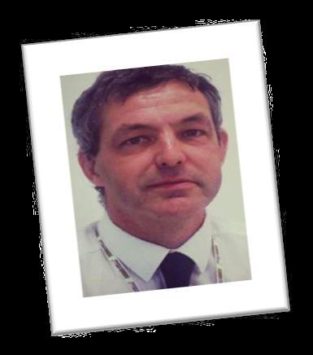

*“Almost universally when I talk to parent carers they*

*are concerned with two things: Ensuring that their child has a great life and anxiety over who will look after*

*their child when they are no longer able to do so.”*

Daniel is a father of three children. His son Oliver, aged 12 years, has Down’s syndrome and his two girls, aged 10 and 6 years, were both diagnosed with Juvenile Idiopathic Arthritis at the age of 18 months. He moved back to Herefordshire in 2007 to be closer to his extended family and to easily access the specialist medical services his two daughters required in Bristol Children’s Hospital.

Daniel shared his experiences as a parent carer and his desire to make every effort to ensure that his children enjoy the same high quality life that would be expected of any other child. He spoke of feelings of guilt, exhaustion

“As difficult as it is, sometimes as a carer it’s the guilt you carry, the feeling actually you are not good enough or you are not up to the task”. The fact that you never asked for any of this and you were never put through a test to see if you were qualified to be a carer.

Daniel shared some challenges experienced being given information that he didn’t fully understand and sometimes poor communication “Sometimes I feel guilty, sometimes its self doubt. We are asked to make 101 decisions about our children and every parent knows you don’t know what the real impact of those decisions will be” He continues to say “The NHS performs miracles every day. Twice Oliver was within in hours of dying, he’s alive, and healthy and he’s enjoying life”. Daniel concluded by reinforcing that really small acts of kindness matter such as making hospital visits more comfortable. “I’ve learnt to trust other people when your child’s life is in the hands of someone else. I’ve changed in a lot of ways and one of those ways is the way I deal with stress anxiety and exhaustion. I’m far more accepting of those things and by accepting them I can move on. I could talk about all the

fantastic things and its joyous experiences, the great things we see, the celebrations

you take in even the small steps you see being achieved. The fact that when you’re

exhausted and working flat out trying to keep things together then

. ***“Actually finding five minutes to have drink a cup of coffee whiles it’s still hot can be treasured”***

**6.0 Workshops**

The conference featured three workshops, each delivered twice during the day. These workshops brought together field experts, carers and professionals

The workshops were successful and there was evident engagement and enthusiasm for acting together on several issues. Comments have been reflected in Appendix B



**6.1 Coping with caring**



Delivered by Pat McCarthy from Carers Wales, this workshop explored ways in which to cope with emotional and physical changes that carers may face in their caring role by identifying the causes of stress and learning healthy ways to deal with them, looking at stress management techniques and discussing and challenging some of the feelings encountered when faced with change

The workshop showed a short emotive DVD during the morning session which portrayed a wife with dementia and the impact on her husband the carer who had insufficient support in place. Overall in this workshop carers shared their experiences which have been themed into feelings, warning signs, impacts and practical coping mechanisms as follows:

***Feelings***

✶ *Stress symptoms*

✶ *Helplessness*

✶ *If younger people aren’t listened to in the same way as adults what can they do?*

✶ *Health deteriorates due to caring.*

✶ *No use if you don’t sleep no one asks how you are, people do not*

*understand*

✶ *Young Carer – “Can’t help mum because she is so tired. It is hard then when I see her struggling “*

✶ *The mind seems to respond in uncontrolled / uninterrupted ways*

✶ *Brains ‘become too full’ and we don’t know how to empty them*

✶ *We can end up feeling the stress of other carers*

✶ *Not knowing what to expect is the worst*

✶ *You feel no one else can do the same job as well*

✶ *Moral responsibility has been lost*

*We can’t manage. The distress suffered trying to care. Unless there are support services and training there for us we are always going to*

*suffer stress*

***Warning signs***

✶ *Lack of sleep*

✶ *Anger*

✶ *Moody*

✶ *Worry*

✶ *Poor ability to concentrate*

✶ *Sweat*

✶ *Tension headaches, neck, back*

✶ *Tiredness*

✶ *Weight loss/gain*

***The impact of emotions***

✶ *Little problems accumulate in to bigger ones*

✶ *Some emotions make it more difficult to ‘do the job’*

✶ *Very aware that other people don’t understand the issues or the*

*cared person*

✶ *Own health problems can take away the joy of caring*

✶ *Young Carers are not believed by Social Services – ‘No way of communicating with them’*

✶ *Young Carer – it’s hard if workers are swapping and changing. We have to cope with change of staff and explain all over again.*

✶ *A friend putting off surgery because of caring duties.*

✶ *Can’t get help and support so making injury worst*



***Practical Coping Mechanisms***

*It is all about balancing and*

*how you cope*

*Delegates encouraged others to develop their own way of* ***u****sing practical techniques in a way that works for them i.e.*

✶ *having a positive attitude*

✶ *Recording favourite TV programmes for cared for person*

✶ *Use jigsaws*

✶ *Remember good things that they had previously done at a different moment in time*

✶ *Escape during times when the cared for person is busy forget whatever you just come from talk to friends*

✶ *Give up smoking: do things with fingers, elastic band weaving*

*Pottery, particularly thumping the clay*

✶ *Meditation*

✶ *piano playing*

✶ *colouring books*

✶ *Cleaning eases anger*

✶ *Talk to friend on tablet (Young carer)*

✶ *Write down an ‘Action Plan’, prepare for eventualities ask yourself - If this happens – that will happen*

✶ *Get involved with things and work as it’s a distraction*

*important for self esteem.*

✶ *Complimentary use leisure passes)*

✶ *Good quality sleep is needed*

✶ *Accept events you can’t control, using things to lose control*

*and let go such as support from friends*

✶ *Limit caffeine and alcohol.*

✶ *Set realistic goals and expectations*

*Forgive yourself for not doing enough, the only consistency is love, let yourself off the hook*

*There are lots of support groups out there. More information needs to go out so everyone knows* ***what’s*** *out there and what they*

*can tap into*

*Get involved in things it’s a distraction*

*that takes you out of yourself and self esteem is important*

The workshop ended with a relaxation stress technique

**6.2 Putting Things Right**



This workshop, delivered by the Putting Things Right Team ABUHB looked at ways in which we can raise concerns informally and formally with the relevant people in

the right organisations.

*Carers often cope*

*‘Cradle to Grave’*

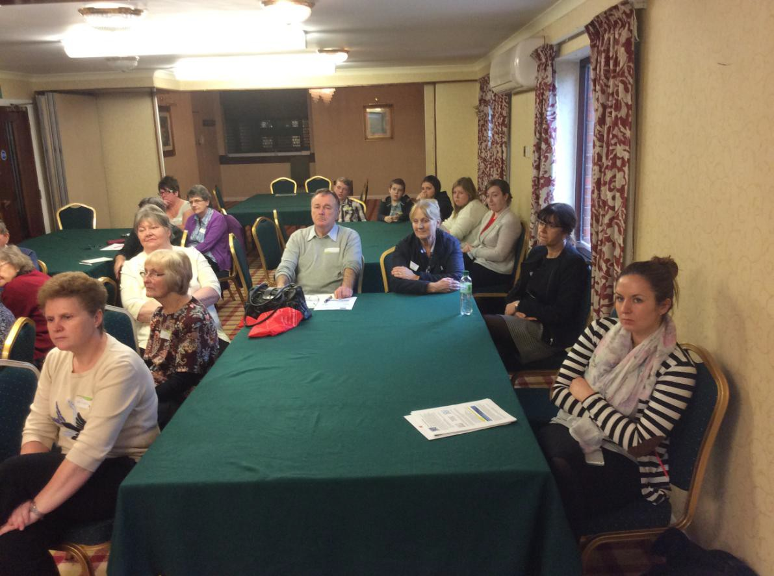

Particular interests in this workshop centred around ensuring that partners listen to feedback, learn from it and use it to improve the care we offer to patients.

The NHS aims to provide the very best care and treatment and it is important that we welcome comments and learn from people’s experiences, good or bad. The vast majority of people are happy with the service they receive. Sometimes though, things might not go as well as expected. When that happens, we need to look at what went wrong so we can try to make it better. We appreciate that often small things can make a big difference.

This workshop looked at the positive and also room for improvement.

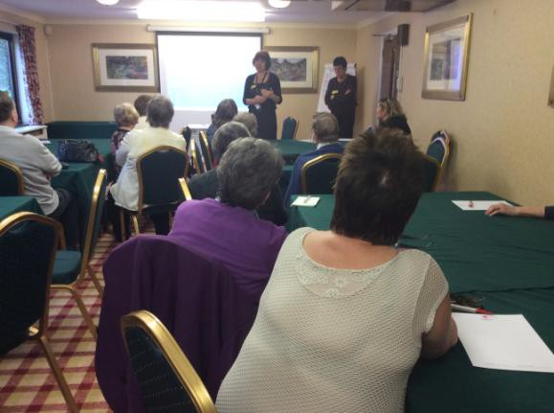

**Some comments received from this workshop are as follows:**

✶ *Complaint system is long winded and inflexible*

✶ *Better understanding is needed of discharge needs*

✶ *Where both people are in hospital at the same time no one explains how things are when both maybe trying to cope for each other’s discharge*

✶ *What’s health mean, what is joint care often they merge provision of extra care*

✶ *(respite) isn’t adapted to individual need*

✶ *Warnings on reactions to medication no information received*

✶ *Going through complaints system can shake care’s confidence enough to undermine their belief that they are giving their best care.*

✶ *Young Carers maybe primary carer but not allowed necessary information*

✶ *Not understood where confidentially agreements to be shared responsibility.*

✶ *There are barriers to feeding crucial information from people who know this person the best and can see changes*

✶ *Patients may be just bed numbers*

✶ *Some members of staff may be better than others*

✶ *It shouldn’t be that carers need to know “the right person” to*

*move their complaint forward*

✶ *Particularly older people may be in awe of clinical staff*

✶ *Not enough skills usually found in most staff to deal with learning disabilities.*

✶ *If carer is involved more respect and care is shown*

✶ *Where GP is familiar with the individuals very helpful adjustments made*

✶ *Some GP’s provide special home visits*

**6.3 Networking and Social Media -Get Connected**

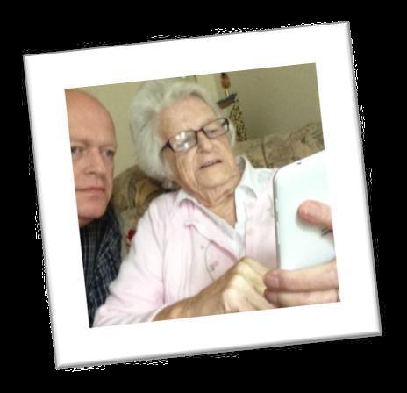

Gary Farr from Age Cymru delivered this workshop which provided a taster session on the role of social media and preventing isolation and loneliness when Carers are unable to leave their loved ones

*This is not about going back to school to learn, it’s all about having fun with technology. No-one should be excluded or lonely in this day and*

*age, after all it’s nifty to be fifty!*

In this workshop attendees learnt how best to keep in touch and keep engaged as well as improving their networking skills.

Practical demonstrations were given from the facilitators (Age Cymru) and some carers talked about their own personal experience of social media. The workshop demonstrated that its value can be seen by its various uses:

✶ *Keeping in touch*

✶ *Making geographical distance less of a problem*

✶ *Helping to reassure both carer and cared for by using visual and graphic communication*

✶ *Finding out information by both receiving and relaying information*

✶ *Embracing the latest technology as an asset to the community*

One example used was a Carer using Skype to call the cared for, each evening, whilst the carer was on holiday. This showed the way technology helped both Carer

and cared for to be sure the other person was OK*.*

*I am an Occupational therapist and it made me think about getting some*

*more support for me as a carer but also making sure that I ask questions of carers I come across and point them in*

*the right direction*

“Although I am fine with computers, I am not so good with tablets and phones learning more on how to use my phone and tablet to connect to e mail and Skype. Age Cymru offered to come out to our group and go through it in more detail”

The workshop gave time for the carers on our table to discuss and share their own experiences

The workshop was very well received as a hands-on, practical and informative workshop which highlighted how technology can and does enhance the lives of carers and those they care for

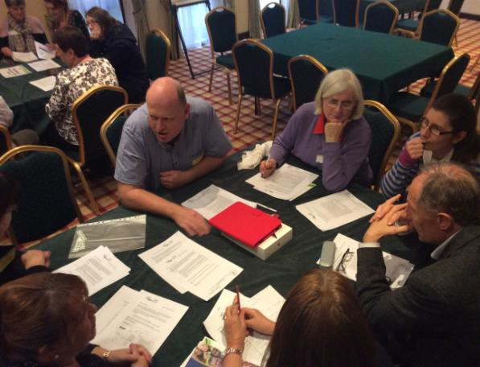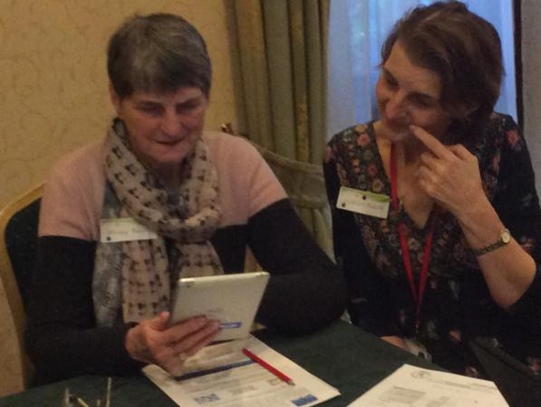

**7.0 Mindfulness**

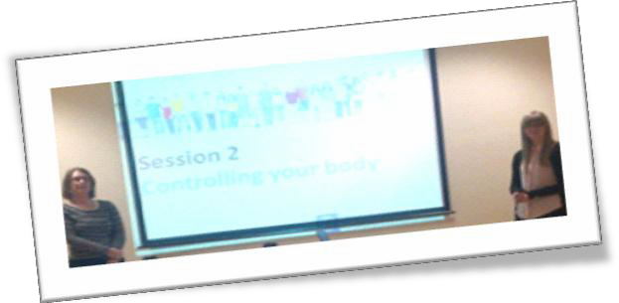

The day ended with a Mindfulness session for all delegates to help delegates relax and ease tension.

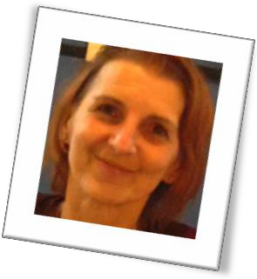

Mindfulness is a very simple form of meditation that focuses on paying more attention to the present moment, your own thoughts and feelings and to the world around you to help improve your mental wellbeing.

This session gave a background to Mindfulness and asked delegates to focus on being compassionate with themselves and , rather than taking things personally, learning to catch negative thought patterns before they tip you into a downward spiral. It begins the process of putting you back in control of your life. It involves becoming more aware of the present moment by noticing the sights, smells, sounds and tastes that you experience, as well as the thoughts and feelings that occur from one moment to the next

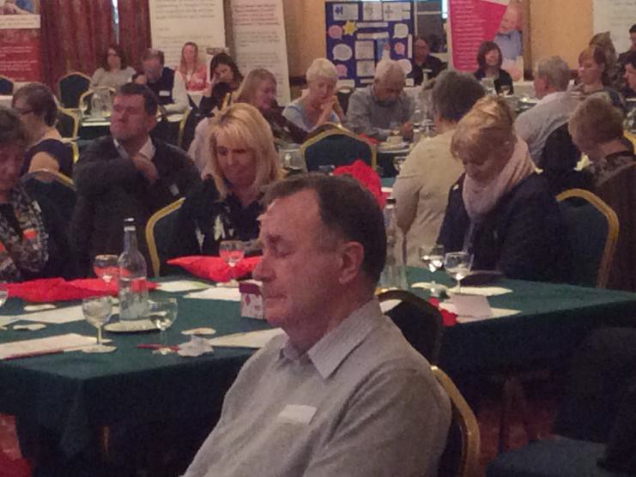

A typical meditation used at this session consisted of focusing full attention on breathing techniques flowing in and out of your body. Focusing on each breath in this way allows people to observe their thoughts as they arise in their mind and, little by

little, to let go of struggling with them. You come to realise that thoughts come and go of their own accord

Over time, mindfulness brings about long-term changes in mood and levels of happiness and wellbeing. Scientific studies have shown that mindfulness not only prevents depression, but that it also positively affects the brain patterns underlying day-to-day anxiety, stress, depression and irritability so that when they arise, they dissolve away again more easily and good mental wellbeing means feeling good about life and yourself, and being able to get on with life in the way you want.

A free Mindfulness DVD was made available to all Carers courtesy of the Marie

Curie Caring for Carers project

**8.0 Evaluation**

Several methods were used to gain feedback at the conference i.e. an evaluation booth, comment boxes and video footage. Comments have been used throughout this report and in Appendix 2

**9.0 Conclusion**

The event demonstrated a wealth of passion and enthusiasm highlighting emerging themes for the ABUHB partnership to build upon that will both recognise and value carers in terms of personal experience and providing support.

It is evident that Carers have asked for clear and accessible signposting information about the support available to them and opportunities to be able to discuss their own situation. Hidden cares still remain an issue so we will continue to use as many ways as possible to reach out to people and raise awareness of carers

The conference was about embracing real partnerships with a strong message that all stakeholders must communicate and work together by listening and learning more to plan for the future.

Everyone was given an equal opportunity to be treated fairly, listened to and feedback in this report allows delegates to know what has been done as a result of their comments from the previous year. It is clear from the conference more discussion needs to take place in terms of making information more accessible and relevant and an increased awareness and training around carers for identifying and signposting would help early intervention and prevention

We recognise and value the voice of carers of all ages. You said and we will keep listening and refining our commitments to improve support to carers. Our objective now is to build on this knowledge and to harness the positive energy and collaborative spirit that characterised the event. Next steps will include continuing to

build positive relationships with all partners involved to ensure continuity of provision and we will continue to offer a high quality service, with service users' needs and desires remaining central to our approach.

**Appendix A**

**Actions from Caring Together Conference 2014**

|  |  |
| --- | --- |
| **YOU SAID** | **WE LISTENED** |
| **Communication and signposting** | |
| Focus services by identifying  and signposting carers at earliest opportunity so that preventative services are in place with health, social services and the third sector all of whom will be required to work in partnership*.* | ✓ Staff training programme is in place (4878 trained in ABUHB)  ✓ Worked jointly with Cwm Taff HB and University of South Wales to deliver Carer Awareness to nursing and social work students. This is now on the curriculum  ✓ Health Board staff are made aware of Carers at induction programmes  ✓ Information is provided at engagement and primary care events across Gwent  ✓ We supported Carers rights day and carers week so that carers have access to the information they need  ✓ We developed a carers leaflet which can be found in your delegate packs  ✓ We are currently in the process of sending out carers signposting information in hospital pharmacy prescription bags |
| Use technology to support carers in accessing advice and information. | ✓ ABUHB Carers web page now in existence for Carers and young  Carers  ✓ Link for existing chat lines ( via Carers Wales) for young people has been put on Webpage |
| Further engagement opportunities need to be  addressed with wider  partners such as Job Centres and Housing Depts | ✓ Signposting leaflets have been sent to Gwent Local Authority housing depts., Housing Associations and nursing homes to  display in their buildings  ✓ We invited carers to identify work experience opportunities in conjunction with DWP. No interest was received but we continue to work with the DWP about raising awareness of carers |
| Better coordination and information sharing across  organisations  e.g. GP’s | ✓ Supported GP surgeries in identifying and signposting Carers by  implementing a Local Enhanced service for Adult and Young carers  ✓ We continue to work with GP’s through our primary care NCN |
| Create Opportunities for  networking between carers | ✓ We have a workshop today on social media and how to get |

|  |  |
| --- | --- |
|  | connected  ✓ We encourage carers to network through events and training and continue to ensure Carers are key partners in implementation of the Carers Measure |
| **Training** | |
| Identify opportunities for Carers to gain appropriate skills development to help  them in their Caring roles | ✓ A Carer Training package has been developed and Local  Authorities will deliver this in their areas. This is the first time there has been a consistent package for Carers across Gwent  ✓ Following feedback from Young carers last year, we explored opportunities for First aid training for Young carers. This will be delivered as a workshop at the young carers event arranged for February |
| Address the lack of emotional support for Carers in being prepared for end of life and  with earlier planning to help cope with the transition | ✓ A pilot workshop, in association with Marie Curie, will be run in the  New Year across each of the Local Authority areas that look at supporting Carers who are looking after someone with a terminal illness. A consultation event including carers was held to pre pilot the content.  ✓ This 2 hour information session that will help prepare Carers to face the challenges and changes of a life-limiting illness.The session will help to:  ✓ Prepare for the difficult times  Understand the feelings you may be experiencing  Look at ways to ease the pain and take care of yourself and Think and talk about what happens when the person you love reaches the end of their life. |
| Continue to train staff across  partnership on carers’ issues | ✓ We have ensured that all the partnership has access to Carers training |
| Carers assessments are given as much attention as the  assessment for the ‘cared for’ | ✓ We continue to work with Local Authorities |
| **Young Carers** | |
| Greater partnership working with schools | ✓ We strengthened links with education by working with schools across Gwent to train teachers on Young Carers. 80% of  comprehensive schools have at least one teacher trained. This has been extended to primary schools  ✓ A teachers training Carers resource pack is being prepared for every school in Gwent and a Young Carers Policy is under development |

**Appendix B**

**Comments from Caring Together Conference 2015**

Individual requests were addressed separately

|  |  |  |
| --- | --- | --- |
| **Comments** | | |
| Listening to all the other comments made me feel and I  am not alone. I found it very helpful to come today. Thank you.  ***Open Honest Discussion good carer’s stories very powerful and need to be told****.*  **An excellent day. Indentified the need for legislation and policies for children. Excellent snack, buffet, tea and coffees.**  ***The Conference was helpful to carers. It gave a good view of what is available*** | Carers need to be heard – Nurses need  to feel valued.  Felt like nurses were slated, carers feel more nurses should attend to hear their stories, most nurses’ care and positive feedback is as valuable as the entire negative. I enjoyed the Young Carers views.  Great Day health care was instinctive | I really enjoyed the  Conference. I care for mum, also work as a Carer Connector for Newport Carers. The awareness and empathy ran throughout the day. “On we March” – Lewis  Great Event, good to see so many carers share many of them are missing out on essential support  Very useful the last film shown was very close to home and useful as we were in similar situation |
| Brilliant day learnt a lot about  other people’s stories. Proud to be a part of the day. Thank you for the opportunity and look forward to the next time | A very helpful and successful venue  supportive to carers  at the moment, who  at times feel so alone which I know myself  from personal experience | What a fantastic event  **Enlightening and enjoyable**  A very informative conference |
| It was a pleasure to be part of  such a well-planned and enjoyable event and especially to work with you. Your commitment to hearing the carers’ voice,  which is not always easy for service providers, succeeded really well. All you hard work paid off. | It was a very good  day and I believe was enjoyed and appreciated by all  .  ***There needs to be***  ***better ways to* communicate between health staff and carers**  . | I enjoyed the conference and it  was lovely to share it with my Mum who has been in a carer's role this year. It's a theme close to my heart. Heather Murray  **There needs to be better ways to communicate between health staff and carers**. |

|  |  |  |
| --- | --- | --- |
| Wonderful patient stories! This is really important forum, and there  should be more of a balance between carers and healthcare professionals. Ensure to get the word out to all areas of Health and Social Care provision –  including STUDENTS to  maximise awareness of carer’s  experiences. A. McDonagh | Good day listening to carers. Thought the  young carers were interesting  Continue to identify more carers It was suggested more outreach work was needed | **Hearing so many different**  **stories, particularly those of young carers was really interesting. There has been a lot of useful help and discussions. I enjoyed listening to the young carers and Carol Wheeler story.** |
| Make the complaints system less  longwinded more inclusive and more flexible so carers feel more empowered. | Dedicated people are needed in health and social services  who can be contacted directly  **All of the Caerphilly Carers that attended have advised that they had a very informative day and thoroughly enjoyed it.** | |
| Greater provision of information and signposting details for  Carers.  **It was suggested that social media be used to increase awareness.**  Greater information is needed on discharge processes.  **Better information is required on services that merge e.g. Health and joint care often merge and provision of extra care isn’t adapted to individual need.**  Greater understanding of confidentiality agreements. | More support is needed from GP’s  i.e. flexible GP appointments and a greater GP  awareness is required of carers situation and the answer is not simply prescribing the carer medication.  It was recommended that Carers access ‘my health online’ a GP service that enables people to book online appointment.  Young carer- Asked to wait in waiting rooms at GP surgeries and struggle to get GP’s and health to understand them  Where GP familiar with the individuals very helpful adjustments are made.  Some GP’s provide special home visits  Do have a wonderful G.P. but would be nice if they had better information to pass on to us. | |

**Appendix C**

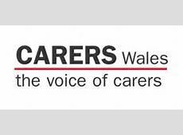

**Exhibitors**

A range of exhibitors were afforded information tables All exhibitors had the opportunity to network and share information. Information was provided from the following.

Community Connecters who work in each Local authority area with people aged 18 years and over who are vulnerable, lack in confidence or are socially isolated.

Young Carers project across Gwent

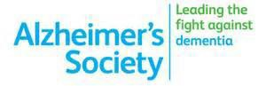

**Appendix D**



**Local businesses donated generously to offer Carers Raffle prizes**

Donated Mindfulness DVDs for all delegates



**Raffle prizes**

